**2.3 Знакомство с manage.py help**

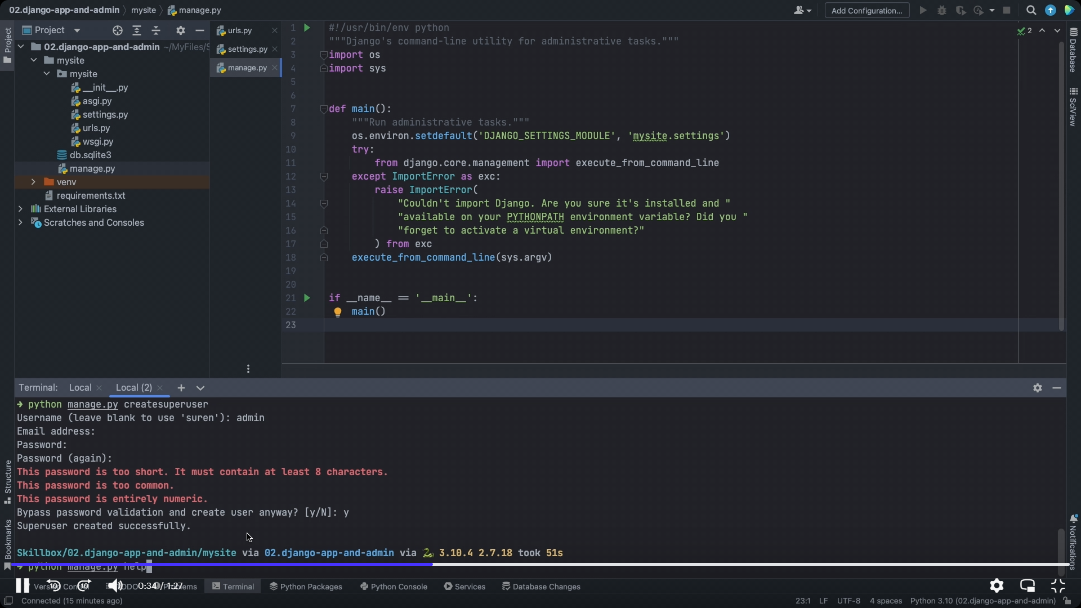 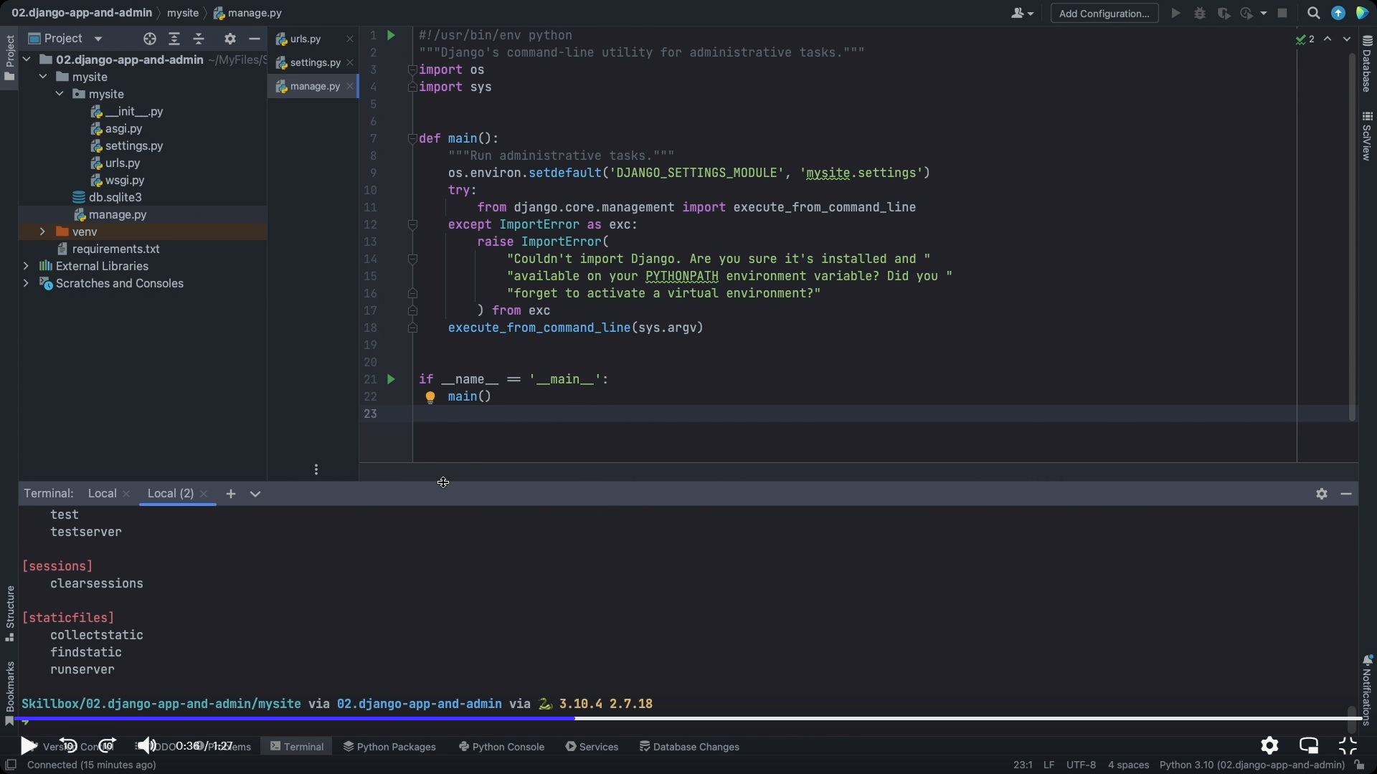 Описание

[URL dispatcher | Django documentation](https://docs.djangoproject.com/en/4.0/topics/http/urls/)